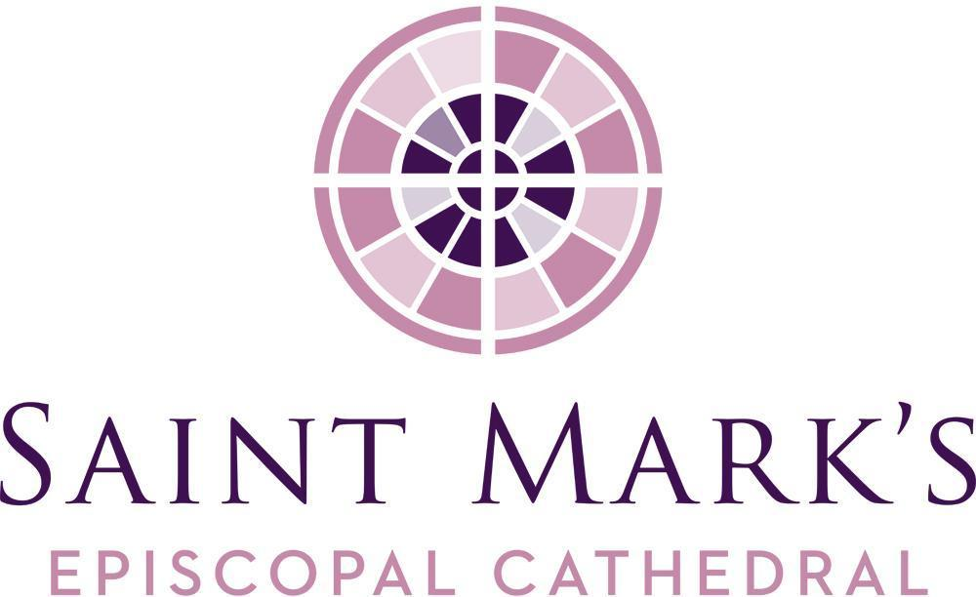
June Vestry Meeting

Minutes
Tuesday, June 23, 2026 6 p.m.
Diocesan House Council Room
Meal Hosts: Amanda and Barbara

Saint Mark’s Cathedral acknowledges that we gather on the traditional land of the first people of Seattle, the Duwamish People, who are still here, and we honor with gratitude the land itself and the life of all the Coast Salish tribes.
Vestry Members Present
Christopher Breunig
Martha Craig, Junior Warden for Facilities
Amanda Davis, Junior Warden for Finance
Phil Haas
Sam Herring
Julia Logan, Senior Warden
Mark Lundquist
Sarah McCord
Michael Monnikendam, Diocesan Member (Zoom)
Deborah Person, Junior Warden for Stewardship (Zoom)
Canon Charles Thorne, Bishop’s Representative
Cynthia Tidwell Stelle, Diocesan Member (Zoom)
The Rev. Gail Wheatley, Diocesan Member
James Wilcox
Vestry Members Absent
John Gulhaugen
Hannah Hochkeppel
The Very Rev. Steve Thomason, Dean
Officers Present
Mary Dickinson, Treasurer
Barbara Erickson, Clerk
Re Knack, Chancellor
Staff Members Present
Marc Aubertin, Cathedral Subdean
Erik Donner, Cathedral Administrator
The Rev. Canon Emily Griffin, Canon Vicar
Senior Warden Julia Logan opened the meeting at 6:03 p.m. with the Land Acknowledgement and the reading of a meditation from Steven Charleston’s Ladder to the Light. Amanda and Barbara were thanked for providing dinner.

APPROVAL OF MINUTES
A motion was made, seconded, and passed to approve the May 26 Vestry Meeting minutes as presented. Deborah was thanked for taking the minutes in Barbara’s absence.
STRATEGIC CONVERSATION
The second half of Joan Chittister’s For Everything a Season was discussed with particular focus on refraining from embracing, the reduction of excess, and learning to say no. Exploration of how this applies to church activities and leadership decisions was discussed, including examples like the Creation Care Ministry and the need for appropriate silence during services.
OLD BUSINESS
Affordable Housing Updates
Julia Logan reported that Uncommon Bridges, the consulting group compiling community profile and engagement reports, will provide its final report to the Affordable Housing Committee in July. Community outreach is underway, including a potential partnership with Wa Na Wari, a center for Black art and belonging. Consultant Kendall Clawson is also building relationships to identify community-based organization (CBO) members. The housing project is expected to have a name by fall 2026.
UW Visual Storytelling Project Updates
Emily Griffin reported that upcoming storytelling project features an eight-panel storyboard exhibition in the nave, with an opening reception scheduled for September 20. The Rev. Adam Conley has taken over leadership of the content group after the previous leader stepped down for pastoral reasons. A larger meeting is planned for July 8 to discuss the purpose of the opening reception and determine appropriate invitations.
Cathedral House HVAC Retrofit
Marc Aubertin reported that wiring, piping, and ductwork installation are underway, along with system updates throughout the building. New control systems are being installed in the staff offices.
Greenbelt Update
Re Knack reported that the trees on the city’s parcel have been removed. Saint Mark’s is awaiting permit approval and the end of nesting season before the trees on our parcel can be addressed.
Financial Accounting/Reporting Transition Update
Mary Dickinson is hopeful the 2025 financial review will be ready for vestry acceptance in August. Julia thanked Mary for the amazing job she is doing!
Design Team
Re Knack provided an update on the Abbott Construction contract, which is nearly complete. She also encouraged vestry members to attend the “teaser” forum on Sunday, October 4, and the Wednesday, October 7 Cathedral Commons forum, where design concepts and drawings will be presented.
July 28 Vestry Meeting
Julia Logan outlined two options if the July 28 meeting is canceled and no new issues arise: skip the meeting, or hold an informal, non-mandatory barbecue at the cathedral. Julia will contact vestry members in July.

NEW BUSINESS
Vestry Letter of Support for Emily Meeks to Transitional Diaconate
Voting members of the Vestry were asked to sign the Letter of Support for Ordination to the Transitional Diaconate for seminarian Emily Meeks. The ordination is scheduled for December 19, 2026 at Saint Mark’s.
Virtual Anti-Racism Training September 26 10:00–3:00
A virtual anti-racism training session is scheduled for September 26 from 10:00 to 3:00 p.m. (similar to the June 13 in-person training). Julia will notify all when the registration link is available.
LEADERSHIP REPORT
Senior Warden
- Attended anti-racism training led by The Rev. Canon Carla Robinson.
- The deanery bathroom project is progressing, especially with the tiling and waterproofing work, including the discovery and repair of small patch of rot in the bathroom floor.
- The parish book discussion, For Everything a Season, was noted as successful with 30-35 attendees showing high engagement for both the June 14 and 21 sessions.
- Steve and Kathy's foster grandson, Toussaint, is now officially their grandson, as he was adopted by their daughter and daughter-in-law!
- Thank you notes from AFEDJ and Clear Mountain Monastery.
MINISTRY/COMMITTEE REPORTS
Worship & Prayer
James and Emily reported that the committee had met, and recent liturgies and a trial lectionary were discussed.
Finance
Amanda thanked Mary Dickinson, Marc Aubertin, and Erik Donner for their work during the transition period.
Stewardship
Deborah shared that this fall’s stewardship theme will be “Boldly Proclaim.” The kickoff dinner is scheduled for Friday, September 25. The committee is exploring ways to encourage conversations about generosity, including partnering with existing meetings/events rather than holding separate ones.
Intergenerational Council
Mark reported that the council’s meeting focused on intergenerational activities and community-building initiatives. The group discussed upcoming events, which include an art making workshop with Sandy Nelson on July 19, an intergenerational hike planned for late August, and intergenerational features at the storytelling project exhibit featuring a cardboard house display as well as a community “visioning station” about affordable housing. Wendy Barrie will be working with Evans Ousley to make the intergenerational newsletter more strategic and community focused.
Restorative Justice Council
Emily provided an update that along with our current partnership with the Washington Immigrant Solidarity Network (WAISN), we are now partnering with the Archdiocese of Seattle. Nine members of Saint Mark’s will attend a June 22 training led by the Jewish Coalition for Immigrant Justice NW.

Accessibility Coordination
Gail stated that she and Hannah are in the midst of liaising between the Accessibility Task Force and the Design Committee, to help answer some open questions for the task force on how their recommendations are being folded into planning in various ways. Gail and Hannah are planning to convene again with the task force in late summer to look more deeply at next steps, by considering some of the recommendations in the task force’s report that are not part of the Design Committee’s work, and can be implemented in other ways. Owner’s representative Spectrum Development Solutions has a relationship with Studio Pacifica, a company that does consulting on ADA requirements, and the company has visited the cathedral.
CHECK OUT & CLOSING PRAYER
After checkouts were given, Erik Donner read the closing prayer on behalf of John Gulhaugen, and the meeting was adjourned at 7:45 p.m.
Respectfully submitted,

Barbara J. Erickson Erik Donner
Clerk Cathedral Administrator

Dates/Events of Note
6/27 Quiet Pride
7/17 Choir Camp Evensong 4pm
7/18 Priesthood Ordinations at SMC
8/1 Cathedral Read In 2-4pm

