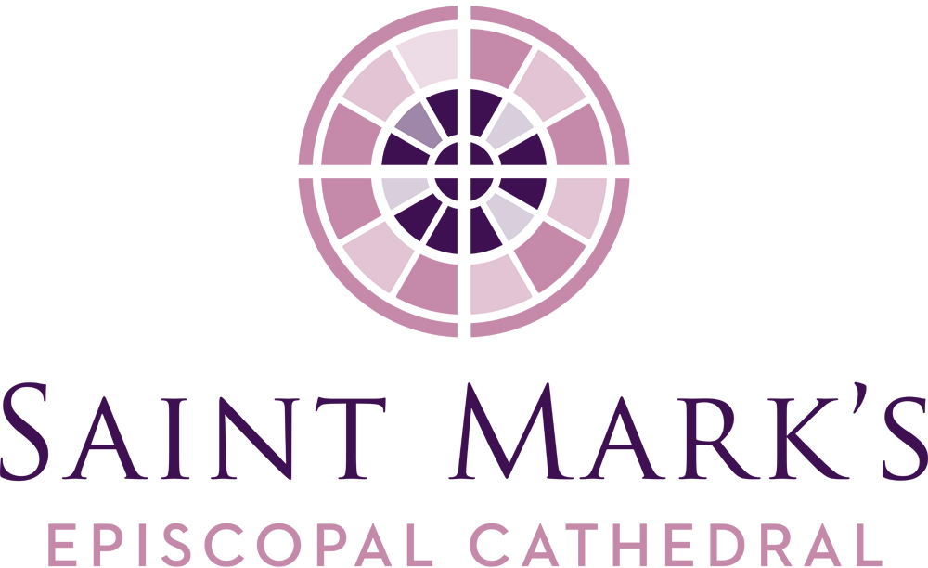
February Vestry Retreat Meeting
Minutes
Saturday, February 8, 2020, 9:00am
Diocesan House Council Room

Vestry Members Present
Kristen Austin
Clara Berg
Carrie Davis
Roberta Kanive
Karla Koon, Diocesan Member
Micah Kurtz, Diocesan Member
Julia Logan
Peter McClung
Emily Meeks
Kari Nasby
Michael Perera
Marjorie Ringness
Robert Stevens
Walter Stuteville
The Very Rev. Steve Thomason, Dean
Officers Present
Barbara Erickson, Clerk
Re Knack, Vice Chancellor
Phil Lloyd, Treasurer
Staff Members Present
Jim Pannell, Director of Operations
Call to Order, Prayer, Review of Agenda, Introductions, Conflict of Interest Forms
Steve opened the retreat with a prayer, the new members of the Vestry were introduced, and conflict of interest forms were completed. The Rev. Arienne Davison provided the Intercultural Development Inventory (IDI) training to the Vestry, and at its conclusion, lunch was enjoyed by all present.
Business Meeting
Steve resumed the meeting at approximately 12:30pm.
Appointment of Chancellor and Election of Treasurer and Secretary
Re Knack was appointed Chancellor by Dean Thomason to succeed John Hoerster, who will serve as Chancellor Emeritus.
A Motion was made, and the Vestry elected Barbara Erickson as secretary by acclamation.
A Motion was made, and the Vestry elected Phil Lloyd to his 10th year as treasurer by acclamation.
Review of Strategic Documents
Steve requested that Vestry members become familiar with the Strategic Plan 2020 and the Saint Mark’s 2030 Plan. Meriwether Partners’ site assessment preliminary report shows viable opportunities do exist for future consideration and the report may be available for the March Vestry meeting. All were reminded the Statement of Commitment and Action is available in the Vestry Resource Document Folder.
Strategic Missional Goals
2019 Mutual Ministry Goals: Planned giving, Racial awareness and reconciliation work, Creating the Strategic Plan, and Creation Care.
Brainstorming session for focus on what the 2020 Mutual Ministry priorities should be took place. Question was to strategically, not tactically, consider our strategic missionary goals. Discussion resulted in the following:
- Listen respectfully
- Welcome and engage newcomers into the parish in combination with expansion of youth in liturgy
- Intentional work this year around cultural competency with a statement about understanding one’s own culture as a key piece of the work.
- Creation Care – just beginning and must continue; inclusion of youth beyond those involved in church activities; involve the wider community; intergenerational perspective – needs a place.
- Best way to utilize our physical assets.
- Progressive, yet “we are quiet,” so no one may know what we stand for, and therefore proclamations are made by others on their perceptions of whom they believe us to be.
Appointment of Senior Warden; Election of Junior Wardens
Before Steve left the room to permit Vestry discussions and decisions, he provided the following definitions: the Senior Warden is appointed by the Dean, it is the practice of this dean to look to the Vestry to raise up the person who will then be appointed to serve. This person acts as the leader in the parish and advisor to the rector and stands in for the dean in his/her absence. The Junior Wardens are elected by the Vestry to address the finances and facilities.
A motion was made and approved by the Vestry to recommend Julia Logan as Senior Warden. Based on this recommendation, Dean Thomason appointed Julia Logan as the Senior Warden.
A motion was made and approved by the Vestry to elect Peter McClung as the Junior Warden for Finance.
A motion was made and approved by the Vestry to elect Walter Stuteville as the Junior Warden for Facilities.
Resolution for Authorized Check Signatures
Phil Lloyd led the discussion and it was determined that the Director of Operations, the Treasurer, the Senior and Junior Wardens, and the Dean will be authorized to sign checks, especially anything above $5,000.00. Phil will ensure all signatures gathered.
A motion was made and approved by the Vestry to authorize the Treasurer to update the check signatures to include the Senior Warden, the Junior Wardens, the Dean, the Treasurer, and the Director of Operations.
Draft Creation Care Earth Day 2020 Project Proposal
Marjorie Ringness summarized the Earth Day NW 2020 proposal as a plan to celebrate the 50th anniversary of Earth Day, and as a stepping off point as a continuing effort to 1) reduce Saint Mark’s carbon footprint, and 2) educate and build awareness of the congregation to the impacts of climate change.
Current status: finalizing the Project Proposal and the Solarc Energy report will be used as a guiding document to prioritize what steps can be taken now and what is better left for the future. The hoped-for goal is to be Net Zero by 2030.
Dates of forums for Vestry attendance:
- March 22 Sunday forum – on our calling to care for God’s creation
- April 19 Sunday forum – presentation with Scott Henson about the concept of “Drawdown”
- April 29 Wednesday Cathedral Commons – follow-up on personal actions to take
- May 9 Cathedral Day – will have a Creation Care theme
- May 20 Wednesday Cathedral Commons – Rogation prayers and blessing of the campus
Initial Conversations on 2020 Mutual Ministry Agreement
The Executive Committee (dean and wardens) will begin to prepare a plan with the data gathered and will present a draft plan for review and comment in March. Brainstorm items to be considered, remembering all may not be included are:
- Listen respectfully
- Welcome and incorporation of new members and youth
- Using IDI as a path for cultural competency
- Creation Care
- Youth engagement
- Cathedral as a resource center for the Diocese of Olympia and broader community
- Intergenerational efforts
- Optimize physical assets
- Identify and advocate who we are to the community
Security System Design and Cost
Jim Pannell has been looking into a security system initiated by the car break-ins when items were visible in parked cars on the premises. These occurred prior to the acts of vandalism to the cathedral. Bids are being sought based on cameras at specific campus locations; additional security cameras can be added if necessary.
A motion was made and approved by the Vestry to authorize the purchase of a security system up to $15,000.
Jim gave a recap of other projects: Solarc Energy has provided their report for review, high-level electrical bid for a number of projects, pest control issues at Gage Academy, painters to figure out how to stripe the playground area parking behind Bright Water School, third report was filed on the recent vandalism as a Hate Crime as it felt aggressive, and warranted locking the cathedral doors, Church Insurance contacted about claims and the deductible, and the metallic paint used to deface the cathedral doors was cleaned off by David Wagner.
Ministry and Committee Liaison Assignments
- Diocesan Members of the Vestry – Micah Kurtz and Karla Koon
- Worship and Music – Walter Stuteville, Peter McClung, and Carrie Davis
- Faith Formation:
- Youth/Children – Kristen Austin and Kari Nasby
- Adult Faith Formation – Roberta Kanive and Emily Meeks
- Justice (JMCT) – Micah Kurtz and Kari Nasby
- Creation Care – Marjorie Ringness and Roberta Kanive
- Hospitality – <Open >
- Communications – Michael Perera
- Stewardship – Robert Stevens and Clara Berg
- Finance – Peter McClung and Robert Stevens
- Facilities – Walter Stuteville and Carrie Davis
- Cathedral Foundation – Steve Thomason
Check out & Closing Prayer
Checkouts were given, and Steve closed the meeting with a prayer at 2:49pm.
Respectfully submitted,
Barbara J. Erickson Erik Donner
Clerk Executive Assistant

Upcoming Events of Note

2/25 Shrove Tuesday/Mardi Gras
2/26 Ash Wednesday
4/5 Palm Sunday, beginning of Holy Week
4/11 Easter Vigil
4/12 Easter Day

