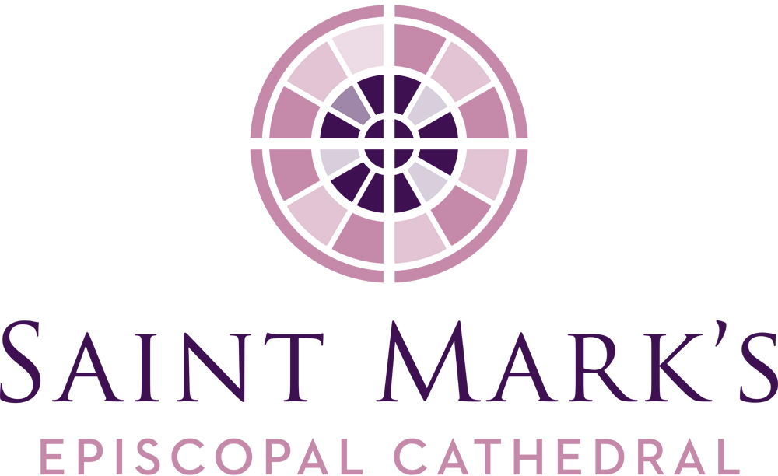
Saint Mark’s Cathedral
January Vestry Meeting
Tuesday, January 21, 2020, 6pm
Diocesan House Council Room

Vestry Members Present
Kristen Austin
Jim Buskirk, Junior Warden
Amanda Davis, Junior Warden
Carrie Davis
Andrew Himes
Roberta Kanive
Micah Kurtz, Diocesan Member via telephone
Rosemarie LeMoine
Julia Logan, Senior Warden
Mary Maxon, Diocesan Member via telephone
Kari Nasby
Michael Perera
Marjorie Ringness via telephone
The Rev. Canon Marda Steedman Sanborn, Bishop’s Representative
Robert Stevens
The Very Rev. Steve Thomason, Dean
Officers Present
Barbara Erickson, Clerk
John Hoerster, Chancellor
Re Knack, Vice Chancellor
Phil Lloyd, Treasurer
Staff Members Present
Erik Donner, Executive Assistant to the Dean
Jim Pannell, Director of Operations
Guests
Lynne Markova – Strategic Plan
Call to Order, Prayer, Review of Agenda
Steve called the meeting to order and opened the meeting with a prayer at 6:00PM. Steve welcomed and introduced Carrie Davis and Kari Nasby, our newly appointed vestry members, and guest, Lynne Markova who will present the Strategic Plan for adoption.
Consent Agenda
The Vestry approved the November 26, 2019 meeting minutes as published.

OLD BUSINESS
Strategic Planning Update
Lynne Markova provide a comprehensive report detailing the process around the updating of the Strategic Plan. A refresh of the five areas of ministry: Prayer, Worship and Music, Faith Formation, Justice and Community Life.
Discussion around sections:
- Where We Want to Go: St. Nicholas “building” will be referenced as St. Nicholas “property” was adopted as a friendly amendment
- Hospitality: Question of use of “radical hospitality,” radical hospitality is a theological statement.
- Justice: Verbiage around “explicitly welcome”
The Vestry approved the amendment to the 7th bullet item to read “Welcome everyone, including those whom our church has historically marginalized including of People of Color, LBQTQIA+, lower-income individuals, and individuals with disabilities.
The Vestry then adopted Saint Mark’s Strategic Plan as amended.
Nominating Committee Update
Lynne reported that the Nominating Committee has provided a full slate of Vestry and Diocesan candidates. The Vestry candidates were introduced to the parish at the 9 and 11am services on Sunday, January 19. Lynne acknowledged the work of the Nominating Committee – Ralph Ermoian, Julia Logan, Mary Mullen, John Selberg, Gerry van Wesep, Dean Steve Thomason and chair, Lynne Markova.
Construction Update
John Hoerster reported that despite the recent lack of communication from Turner Construction, the parties involved continue to work toward a resolution.
Appointment of Diocesan Member of the Vestry
Steve reported that Karla Koon, St. Andrew’s, Seattle, has the concurrence of Bishop Rickel to be a Diocesan Member to the Vestry. She will attend the February 3 orientation and the February 8 retreat.
The Vestry appointed Karla Koon as a Diocesan Member of the Vestry, with a term ending January 2023.
NEW BUSINESS
Employee Handbook Revisions
Steve opened discussion with the document having significant changes in State and Federal laws in leave benefits, and minor edits elsewhere. If someone wants to take leave and has to initiate this new Washington State process, the complexity will require legal counsel be retained for guidance.
- Section 6.3.1 paragraph 1, sentence 1 and for consistency, removal of “male and female” reference throughout.
- Section 5.9 “Contact Facilities” will be changed to “Contact your supervisor...”
- Her/His reference to be changed to “Their.” Review of state code so intent is not changed.
The Vestry adopted the January 2020 Employee Handbook as amended.
Prospective Renovations to Narthex and Bathrooms
Steve explained the need, from a hospitality standpoint, to update the narthex, the narthex bathrooms and the lack of an all-gender bathroom. Interim plans are to convert the existing bathrooms between the choir room and child care center on the 5th floor to be all-gender bathrooms. A focused campaign is proposed to engage an architect to provide designs for the narthex, narthex bathrooms and the all-gender bathroom. Concern was raised about financials as the outcome of the construction arbitration and the current expenses for ongoing maintenance projects. This project would be a separate budget.
The Vestry approved the motion to proceed with architectural consultation to provide design drawings and the identification of how to fund the renovations.
Carbon Reduction Initiatives
Andrew reported that the Creation Care Ministry is growing and preparing for two Sunday forums: March 22 and April 19. Scott Henson, Project Drawdown, will be the guest speaker at the April 19 forum. A community conversation will take place at the Wednesday evening forum, June 10. Mike Hatten, Solarc Energy, is currently engaged in a carbon analysis of the Saint Mark’s campus to support our efforts for carbon net zero emissions plan.
Steve reminded all that a line item is in the budget for the Carbon Reduction Initiative and it includes replacing: the bike rack, the can lights (bulbs) and fixtures in the nave with LED fixtures, and the installation of two electronic vehicle charging stations in the south end of the lower lot.
Marjorie reported the Seattle Service Corps is piloting the Ridwell recycling service. This is a practical way to recycle plastic, film, batteries and Styrofoam and reduce landfill waste.
Vandalism
The appearance of graffiti on the west wall of the cathedral today is another act in a string of occurrences that prompted a search for a comprehensive security system, including cameras on campus, by Steve, Jim Pannell, and David Wagner. Five vendors have been contacted to quote pricing on a cloud-based system which may be monitored by a small group. Reaction to graffiti as “hate speech,” but this is not at the level of what the synagogues and Black churches experience – feeling of being unsafe. Discussion occurred that we have a choice in how we respond; we can disagree on how our country operates, we can still worship together.
LEADERSHIP REPORTS
Senior Warden
- Julia expressed her appreciation to everyone involved for the wonderful Advent and Christmas services (including O Antiphons and the Pageant) and Epiphany Lessons & Carols.
- This has been an amazing and very fulfilling year, and with some members leaving the Vestry, you will be missed, and she reminded them that Vestry meetings are open to the public.
- Working on broadening her own prayer practice since the Women’s Retreat. Tactile objects are very meaningful, so she presented each member with an icon and prayer token.
Dean
- Andrew Himes, Amanda Davis, Jim Buskirk, Rosemarie LeMoine, and Mary Maxon are still Vestry members until the elections at the Annual Parish Meeting on Sunday, January 26.
- Radix groups are meeting. 150+ members signed up and are assigned to 17 different groups.
- File folder:
  - Letter from Bishop Rickel. He’s staying!
  - Letters of agreement for Associate Clergy. Updated and signed.
  - Live stream analytics for 2019. Continues to grow. Christmas and Easter had thousands of viewers.
  - Threshold Fund Quarterly Report. Third quarter of continued good work.
  - Donor List 2019. Every giver/household/church is identified – about 1,000 donors.
  - Intercultural Development Inventory (IDI) assessment needs to be completed for the February 8 retreat.
  - April – London to meet with Archbishop of Canterbury and Sam Wells, rector of St. Martin-in-the-Fields. Multicultural community resource center brought about by revitalization. Then north to visit with the dean of Christ Church, Oxford.
  - Relationship building continues with The Rev. Dr. Carey Anderson, First AME Church. He will preach at Saint Mark’s on May 17 and Steve will be preach at First AME Church in the fall. What would a civil rights pilgrimage with people from both congregations and covenant together?
  - Michael Kleinschmidt will be on sabbatical for three months – May through July 2020.
  - Marda’s role on the Vestry ends tonight, January 21. She is the interim priest at St. Margaret’s, Bellevue, but on March 1, she will be there full-time, and once a rector is called, she will retire. Bishop Rickel has not announced who will replace her as the Bishop’s Representative.
  - John Hoerster is leaving as the chancellor and Re Knack will assume the role.

Ministry/Committee structure and Reports
Diocesan Members of the Vestry
Mary Maxon, St. Luke’s, Vancouver: Things are good at St. Luke’s; serving a hot meal on Friday and Tuesday mornings to 50 – 60 people.
Micah Kurtz, St. Columba’s, Kent: Reading Barbara Brown Taylor’s book, Holy Envy, for their forum; conversation with student congregation and Congolese choir.
Worship and Music
Amanda: Committee met today. Reviewed Advent/Christmas and planned Lent/Holy Week/Easter.
Faith Formation—Children/Youth
Kristen: The Pageant and Play of Daniel especially was a good experience for them.
Creation Care
Marjorie: A meeting with the parish youth will take place on January 26.
Communications
Michael: Sundays & Beyond will be going out on Friday mornings and will contain new material. The History of St. Mark’s Episcopal Cathedral is now available for online purchase at Elliott Bay Book Company. The Rubric will be published at the end of January and will list all donors, and the May issue will be published after Easter. Thank You for your ministry reports for the 2019 Annual Report.
Stewardship
Robert: 439 pledging households for $1,500,096, with a budgeted amount of $1,535,000. More financial commitments to come!
Finance
Phil: “Above the line” numbers in surplus. Growing upward trend.
Cathedral Foundation
Steve: Underwent an exercise to determine what their mission is, and proposed bylaw changes will be presented at the Foundation’s annual meeting on February 10.
Check out & Closing Prayer
Checkouts were given, and Andrew closed the meeting with a poem that he wrote, “A Prayer for the Vestry Meeting at Saint Mark’s.” The meeting was adjourned at 7:49pm.

Respectfully submitted,

Barbara J. Erickson Erik Donner
Clerk Executive Assistant

Dates/Events of note
1/26 Annual Parish Meeting
2/3 New Vestry Orientation
2/8 Vestry Retreat

