Saint Mark’s Cathedral

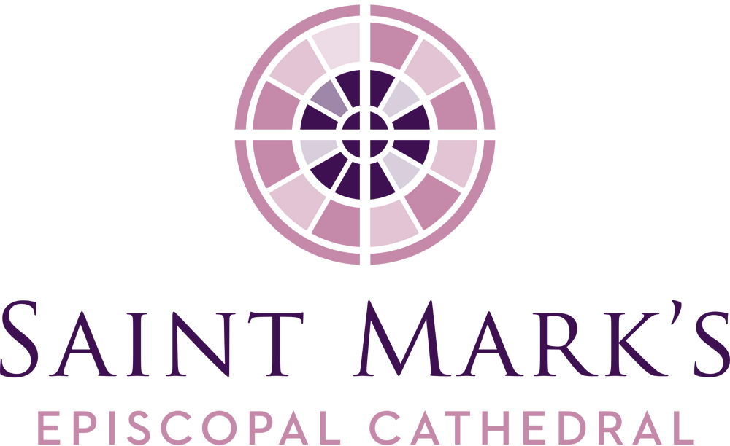
March Vestry Meeting
Tuesday, March 24, 2020, 6pm
Zoom Video Conference

Vestry Members Present
Kristen Austin
Clara Berg
Carrie Davis
Roberta Kanive
Karla Koon, Diocesan Member
Micah Kurtz, Diocesan Member
Julia Logan, Senior Warden
Peter McClung, Junior Warden
Emily Meeks
Kari Nasby
Michael Perera
Marjorie Ringness
Robert Stevens
Walter Stuteville, Junior Warden
The Very Rev. Steve Thomason, Dean
Officers Present
Barbara Erickson, Clerk
Re Knack, Chancellor
Phil Lloyd, Treasurer
Staff Members Present
Erik Donner, Executive Assistant to the Dean
Jim Pannell, Director of Operations
Guests for Executive Session
Amanda Davis, former Junior Warden
John Hoerster, Chancellor Emeritus
Lynne Markova, former Senior Warden
Call to Order, Prayer, Review of Agenda
Steve called the meeting to order and opened the meeting with a prayer at 6:00PM.
Consent Agenda
The Vestry approved the January Meeting Minutes with an amendment to change “tactical objects” to “tactile objects” in the senior warden’s report. The Annual Parish Meeting Minutes and February Meeting Minutes were approved as written.

Executive Session of the Vestry
Chancellor Emeritus John Hoerster was thanked by the dean for his efforts in helping to bring Saint Mark’s and Turner Construction to a mutually satisfactory resolution regarding the unfinished construction project.
Special Order of Business
- Pandemic-related issues
Steve reviewed the steps the Cathedral is taking to keep the parish informed; provide the livestream Sunday services; hopes that pledges and contributions continue to be fulfilled; and noted how livestreaming will occur with the new “shelter in place” order.
- Contingencies, staffing, finances
Anticipate a downturn of revenue as people lose jobs or are laid off resulting in a revision to their pledges. The Cathedral is trying to be creative yet responsible with spending and contingency plans being developed. Asked about the Operating Budget, Steve replied that there is not a lot of “wiggle room” with staff compensation and benefits being 60% of the budget, building being 20% and an additional 20% for other miscellaneous items. Re noted that our Church Insurance policy has an exclusion for Civil Authority Rulings and that arrangements can be made for parishes having difficulty making their premium payments.
- Vestry leadership and response in this extraordinary time
- Being asked to participate as fully as you can with social media to livestreaming to contacting friends.
- Vestry members are asked to make 30 phone calls to reach out to members of the parish. A script, list of parishioners, and contact information will be provided. The calls are to be completed by April 5.
Our sanctuary guests, Jaime, Keiko, and Yoshi, are doing well. A larger challenge exists for our partners at Casa Latina, whose day workers are experiencing financial and wellness impacts. We are sending Casa Latina funds and have also written checks of about $5,000 in support to people being impacted by the coronavirus, grocery cards for the Lowell Elementary children in need, in support of parishioners, and to the Bishop’s Emergency COVID Relief Fund.
OLD BUSINESS
Carbon Reduction Initiatives/Creation Care
Marjorie reported that with the cancellations of the April and May workshops, discussions may happen via Zoom. Drawdown is scheduled to be the topic of the April 19 meeting and the Vestry is invited to attend.
Suggestions were made that during this crisis, the use of social media be explored, to look at the changes we have made these last two weeks and what we might want to continue with, and Marjorie offered that the similarity between the COVID-19 crisis and the crisis of climate change could be shared with the wider community. An example offered was the “shelter in place” may be increasing water consumption as we wash more dishes and do more laundry and not overuse resources. This presents Creation Care an opportunity to offer tips or just present this or other awarenesses.
Marjorie also mentioned that Creation Care members would like to see a more formal form of support of Creation Care from the Vestry since the 2030 Goal has no action plan for the next steps for reaching this goal.
The vestry voted to endorse the Creation Care Ministry’s vision statement as written in their Work Plan.
IDI Training Follow-up and Next Steps
As The Rev. Canon Arienne Davison transitions into her new role as Canon to the Ordinary, and with the COVID-19 interruption, staff and vestry members seeking to meet with her for individual consultations about their Intercultural Development Inventory assessments are asked to wait a few more weeks.

Mutual Ministry Goals for 2020
Steve presented the three proposed goals identified by the Executive Committee as potential focus areas in the Mutual Ministry Goals for 2020. It was clarified that cultural awareness and growth (the focus of the Intercultural Development Inventory), while not one of the Mutual Ministry goals stated in this document, continues nevertheless to be an integral part of the 2020 Strategic Plan.
The Vestry voted to adopt the 2020 Mutual Ministry Goals as written.
NEW BUSINESS
Parochial Report
The Vestry approved the adoption the 2019 Parochial Report for Saint Mark’s as presented.
Revisions to Safe Church Policies
Re Knack provided background stating that the policies addressing the safeguarding of children and vulnerable adults were adopted a year ago. Appendix A has been amended to update the grid of the positions in the church and the training required. At that time completed, Appendix A was not as robust as it should have been, The Rev. Canon Cristi Chapman has been working on updating the grid with the appropriate training and to address those that are not readily accessible. The change to the two policies involved public records check and updating of certificate of training to take place every 5 years rather than every 3 years. As the use of “depends” in Appendix A left the meaning open, it was asked that an asterisk be added to the bottom of the page identifying the criteria.

The Vestry voted to adopt the revised Policy for the Protection of Children and Youth and the Policy for the Protection of Vulnerable Adults (including Appendix A) as presented.
Cathedral Foundation Three-Party Agreement Revision
Steve explained the Three-Party Agreement term comes from the Vestry, the Bishop and the Foundation Board each appointing 1/3 of the members. The revision involves the rightsizing of the Board and to focus its mission more clearly.
The Vestry voted to accept the Cathedral Foundation Three-Party Agreement as revised.
Pay Off St. Nicholas Mortgage/LLC Gift
The Finance Committee is recommending the mortgage loan for St. Nicholas Building be paid off as our LLC partner would like to deed their 50.5% to the Cathedral so the Cathedral will own the property outright. This is a $4–5M gift to Cathedral, with one stipulation – the LLC partner does not pay excise tax on the gift amount which would be incurred if there was still debt on the building.
This would be an expense of $500,000 including the pre-payment penalty. We have adequate reserve funds on hand to handle this short-term transaction. Concerns were raised about the current economy with the COVID-19 pandemic and the financial impacts. A quick recovery of the funds is anticipated through the cashflow from the St. Nicholas rentals. The $500,000 is coming due within the next three years anyway so the payments are just being accelerated. In recent discussions with Bright Water, the school is fully committed to Saint Mark’s during this period and is not seeking rental reductions.
The Vestry voted to authorize a $500,000 payment to Bank of America to pay off the outstanding loan on the St. Nicholas Building.
Cathedral Representative on Bishop’s Visitations
Tabled until Bishop Rickel begins his visitations again.
Request for a Listening Process – Nuclear Disarmament
Julia provided background for the Justice Ministries Coordinating Team’s (JMCT) request for a Listening Process for the Cathedral’s endorsement of the Washington Against Nuclear Weapons Coalition. This was discussed at an Executive Committee Meeting and is now being presented to the Vestry for discussion. The Vestry has four actions it can take: 1) Reject, 2) Endorse without the Listening Process, 3) Send the request back to JMCT for clarification, or 4) Vote to hold a Listening Process. The primary options for consideration being options 1, 3, or 4.
The Vestry had many questions about the proposal and felt they need more clarification about what is expected, as well as needing to understand the Listening Process. Parishioner Betsy Bell will be asked to attend a Vestry meeting to help clarify concerns.
LEADERSHIP REPORTS
Senior Warden
- The Vestry is tentatively scheduled to provide refreshments for Coffee Hour on Sunday, May 3, and Cathedral Day is tentatively scheduled for Saturday, May 9. The Cathedral Day theme is “Renewing the Face of Creation” and the Vestry will be asked to help in the morning with greeting and directing traffic.
- Call, text, or email congregants to see how they are doing. The response from those contacted is that they really appreciate hearing from someone on the vestry.
Dean
- Bishop Rickel appointed The Rev. Canon Marda Steedman Sanborn as Honorary Canon, which is a lifetime appointment.
- Provided pastoral care to hundreds and hundreds, and they are appreciative of how we are maintaining connections.
- Holy Week plans are being modified for livestreaming.
- Robert Stevens’ Nomination for Postulancy will be delayed for two or three months in order that we may meet with Robert and his Discernment Committee in person.
Ministry/Committee Reports
Diocesan Members of the Vestry
Micah Kurtz, St. Columba, Kent: Livestreaming Sunday services, Wednesday night service is held on Zoom, “Buddy Group” formed to check in on one another in smaller groups to stay connected.
Karla Koon, St. Andrew’s, Seattle: Prerecording of Sunday worship services, leading their Wednesday Evening Prayer service, and is now editing video.
Faith Formation—Children/Youth
Kristen: Rebekah has done a good job with keeping the kids involved and actively learning; Kelly is coordinating a second Radix Group using Zoom; livestreaming and connecting families.
Faith Formation—Adult
Roberta: Left Cristi’s orientation encouraged and supported by knowing they will work well together and offer fresh, creative ideas.
Emily: Opportunities with leveraging of digital platforms to remain connected.
Communications
Michael: Established a new Community Facebook Group and Online Community Life page on website for reflections; the livestreaming figures for the Sunday service are high with feedback from near and far; the preliminary response of David Wild’s video of the Stations of the Cross with The. Rev Canon Jennifer King Daugherty is very positive, and will be available closer to Holy Week.
Stewardship
Robert: Meeting was planned, but postponed due to the virus; met with Cristi and Lynne Markova for an impromptu Zoom meeting and will try to hold a Zoom meeting at the end of the month. Pledge information: Budgeted $1,535,000 and currently 464 commitments for $1,554,116.
Finance
Peter: Note the first reports from the conversion to QuickBooks; numbers look good; income from January and February for pledge donations includes 2019 pre-payments.
Phil: Transition to QuickBooks is moving along; statistics are meaningful to the Finance Committee; income statement includes separate tabs for Saint Mark’s operations, St. Nicholas, and Seattle Service Corps.

Check out & Closing Prayer
Checkouts were given and the closing prayer was offered by Steve and the meeting was adjourned at 8:23PM.

Respectfully submitted,

Barbara J. Erickson Erik Donner
Clerk Executive Assistant

Dates/Events of note
4/5 Palm Sunday, beginning of Holy Week
4/11 Easter Vigil
4/12 Easter Day

