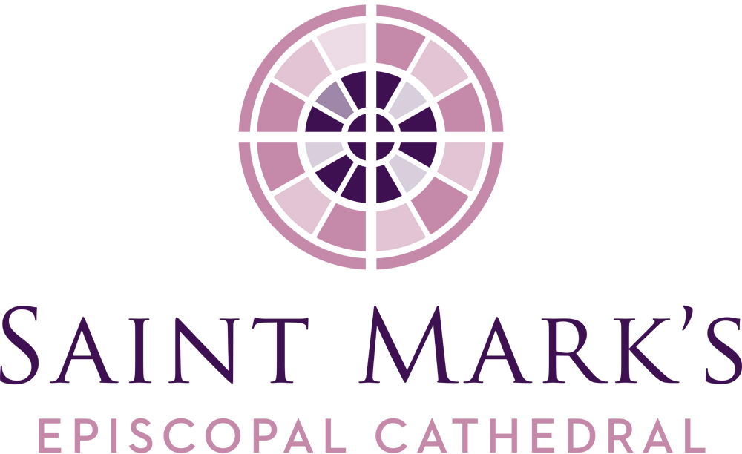
Saint Mark’s Cathedral
November Vestry Meeting
Tuesday, November 26, 2019, 6pm
Diocesan House Council Room

Vestry Members Present
Kristen Austin
Jim Buskirk, Junior Warden
Amanda Davis, Junior Warden
Roberta Kanive
Micah Kurtz, Diocesan Member
Julia Logan, Senior Warden
Mary Maxon, Diocesan Member
Michael Perera
Marjorie Ringness
The Rev. Canon Marda Steedman Sanborn, Bishop’s Representative
Robert Stevens
The Very Rev. Steve Thomason, Dean
Vestry Members Absent
Andrew Himes
Rosemarie LeMoine
Officers Present
Barbara Erickson, Clerk
John Hoerster, Chancellor
Re Knack, Vice Chancellor
Phil Lloyd, Treasurer
Staff Members Present
Erik Donner, Executive Assistant to the Dean
Jim Pannell, Director of Operations
Call to Order, Prayer, Review of Agenda
Steve called the meeting to order and opened the meeting with a prayer at 6:00PM.
Consent Agenda
The Vestry approved the October 22, 2019 meeting minutes as published.
OLD BUSINESS
Construction Update
John provided a status on the settlement offer that was made to Turner Construction.
Stewardship Update
Robert reported that as of November 22, we have received 379 pledges totaling $1,407,571 for 2020. Ministry debrief on December 19, with a full report at the next Vestry meeting. The Dean mentioned that the average pledge in 2019 was $3159, increased in 2020 to $3714. Over the past seven years, the pledge base has increased 57%.
Strategic Planning Update
Julia reported the interviews with the ministries and parish surveys are complete. The compilation of data will begin and the report to the Vestry will be given in January 2020.
Nominating Committee Update
Julia reported that seven of the eight vestry candidates have been identified and several potential candidates are discerning. 11 of the 12 Diocesan Convention delegates have been identified.
Filling Vestry Vacancies
Steve provided a recap of the October discussion to fill the two vacant positions. The Nominating Committee, the Dean and Senior Warden met, and Steve presented the name of Kari Nasby to fill one of the one-year terms.
The Vestry unanimously approved the appointment of Kari Nasby to fill the one-year unexpired term on the Vestry (ends January 2021).
Steve then proposed Carrie Davis as the second nominee. Short discussion ensued as to having daughter-mother on the vestry. Amanda’s term will be over, and during the short time they both will be on the vestry, Amanda will recuse herself if required.
The Vestry approved the appointment of Carrie Davis to the Vestry to fill the second one-year unexpired term on the Vestry (ends January 2021).
Solarc Assessment-Carbon Reduction Plan
Steve provided an update that preliminary work has begun with Solarc Energy Group with the help of Jim Pannell and Marjorie, Care Creation. The contract with Soarc was approved in September with the goal to reduce our carbon footprint to become net carbon zero.
NEW BUSINESS
2020 COLA for Staff
Steve discussed the 2.3% cost-of-living adjustment for all Saint Mark’s staff recommended by the Finance Committee. This parallels what the diocese adopts and what the clergy receives and is drawn from the Consumer Price Index.
The Vestry approved the recommendation from the Finance Committee to adopt the 2.3% cost-of-living adjustment increase for the staff for 2020.
Proposed 2020 Budget
A balanced budget is being presented in the operating budget. Total revenue of $2 million plus, and a total expense of $1.963 million leaving a surplus of $79,879 in the operating budget.
Review of the “Below the line non-operating revenue/expenses” reflects that the Choir School, which has been moved into this category for tracking purposes, shows a $117,377 budgeted expense which uses the surplus $79,000 number.
The Vestry approved adopting the 2020 budget as presented.
WA State Sick Leave Law/Employee Premiums
Last year, the Chancellor and Executive Committee recommended both the employer and employee premiums be covered by the cathedral for 2019. The premium for the staff was approximately $3400. In 2020, proposing a graduated process to transition the portion of the premium that is the employees’ responsibility to the employees. To ease that transition, at the end of 2019, an extra payment will be given to each employee to cover cost of the employee’s portion of the premium in 2020; this will be reflected on their pay stubs. In 2021, this becomes the employee’s responsibility.
The Vestry approved the motion to transition the burden of the employee’s premium by paying each emplpyee the equivalent of the 2020 premium as an extra payroll payment in December 2019. In 2021 the employee’s portion of the premium will become the employee’s responsibility.
Site Assessment Proposal
Meriwether Partners has been engaged to provide a site assessment for the entire Saint Mark’s campus excluding the cathedral building. The diocese will provide $5,000 toward the $22,500 fee. Request is the authorization of $17,500 from the surplus 2019 funds to provide the assessment.
The Vestry approved the motion to authorize $17,500 for the site assessment to be conducted by Meriwether Partners.
Nave Sound System Issues
In 2017, the Federal Communications Commission began selling off portions of broadband frequencies – 600 MHz – which our wireless mics use. The current wireless mics need to be replaced with a newer 400 MHz range technology. As of July 2020, all wireless microphone systems will be required to stop using the 600 MHz range. Purchase of the four-mic wireless system will be $13,659. The soundboard will work with the new system but this may be a potential issue in the future.
The Vestry approved the request authorizing $13,659 for the new Lift AV wireless mic system.
2020 Vestry Calendar
The Vestry voted to adopt the 2020-21 Vestry calendar as proposed.
Clergy Housing Resolution
The resolution reports the housing allowances for Jennifer, Cristi, and Nancy for next year. Steve’s housing is provided by the church and is not included.
The Vestry adopted the 2020 Housing Allowance for the clergy employed by Saint Mark’s Cathedral.
Cathedral Foundation Mission Review
Foundation’s board retreat was held, and conversation had about its mission, purpose. Identification of things it has been doing and what things should be perhaps done by the Foundation, Diocese, Vestry. Discussion will continue in February and then presented to the Vestry.
December Vestry Meeting
Steve entertained a motion to cancel the Vestry’s December Meeting.
The Vestry unanimously approved the cancellation of the December 2019 Vestry meeting.
LEADERSHIP REPORTS
Senior Warden
- Successful Diocesan Convention. Thank You for all the help especially for the cookies; good comments about the cathedral construction, the labyrinth, and Cathedral Day. Also had two comments regarding the closing of the Cathedral Shop.
Dean
- Thanksgiving service at 10:00am, 7:00pm O’ Antiphons on the First Sunday of Advent (December 1); Pageant of the Nativity is 7:00pm Tuesday, December 17 and Blue Christmas on Thursday, December 19.
- Christmas Eve services are 4:00pm, 7:30pm and 11:00pm with carols before each service. 2500 anticipated in attendance over the two days.
- Stewardship is going well with 57% increase over seven years.
- Iona Pilgrimage has five spots left. 25 have currently signed up.
- Deacons Earl and Emily have been reappointed by the Bishop and will remain at Saint Mark’s.
- File folder:
  - 20 – 30 Master Plan provides background information related to the site assessment.
  - Front Door Ministry – not a huge number, most are coming to visit the cathedral, hospitality
  - Alissa Newton, Vicar at St Columba, Kent, shared a photo of the copper cross given to the parishes from Century II campaign.
  - Grateful to be here serving in our midst and for vestry and community spirit moving.
EXECUTIVE SESSION OF THE VESTRY
2019 Mutual Ministry Goals were reviewed by the Vestry with a report to follow.
Check out & Closing Prayer
Checkouts were given, and Marjorie gave the closing prayer. The meeting was adjourned at 7:52pm.

Respectfully submitted,

Barbara J. Erickson Erik Donner
Clerk Executive Assistant

Dates/Events of note
12/1 O Antiphons
12/17 Pageant of the Nativity
12/19 Blue Christmas Service
12/31 Labyrinth Walk and Midnight Eucharist
1/5 Epiphany Lessons and Carols (4:30pm)
1/26 Annual Parish Meeting

