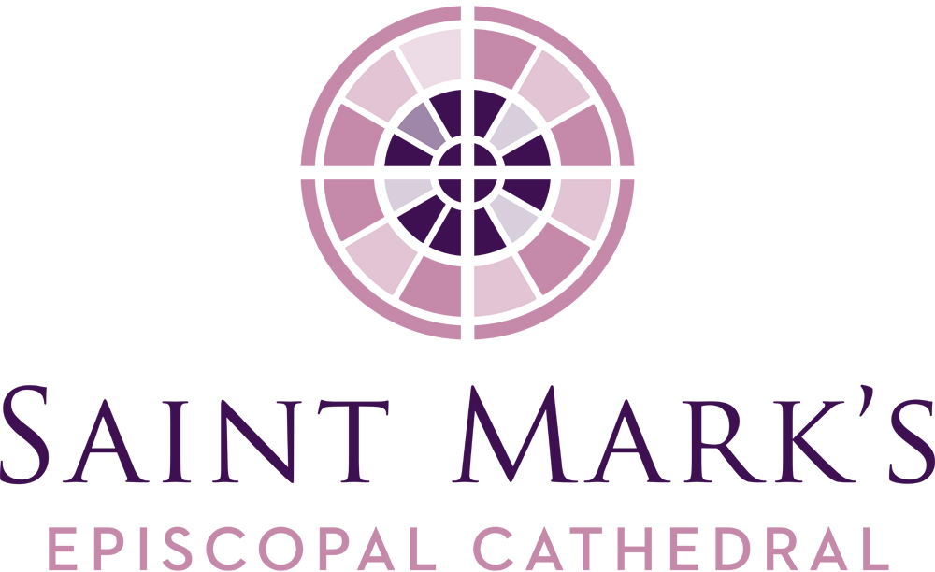
Saint Mark’s Cathedral
October Vestry Meeting
Tuesday, October 22, 2019, 6pm
Diocesan House Council Room

Vestry Members Present
Kristen Austin
Jim Buskirk, Junior Warden
Amanda Davis, Junior Warden
Andrew Himes
Roberta Kanive
Micah Kurtz, Diocesan Member
Rosemarie LeMoine
Julia Logan, Senior Warden
Mary Maxon, Diocesan Member
Michael Perera
Marjorie Ringness
The Rev. Canon Marda Steedman Sanborn, Bishop’s Representative
Robert Stevens
The Very Rev. Steve Thomason, Dean
Officers Present
Barbara Erickson, Clerk
Re Knack, Vice Chancellor
Officers Absent
John Hoerster, Chancellor
Phil Lloyd, Treasurer
Staff Members Present
Erik Donner, Executive Assistant to the Dean
Jim Pannell, Director of Operations
Call to Order, Prayer, Review of Agenda
Steve called the meeting to order and opened the meeting with a prayer at 6:00PM.
Consent Agenda
The September 24 Vestry minutes were corrected to reflect the “Lutherans will be installing their priests” under the Dean’s Report and in the Senior Warden report, the topic for the Inquirer’s Class is Anglican “charism.” The Vestry approved the September 24, 2019 minutes as amended.
OLD BUSINESS
Construction Update
John and Steve continue to have conversations striving for settlement.
Stewardship Update
Erik gave the following statistics: As of October 18, 92 pledges totaling $370,122 were received for 2020, and 50 of those were increases from 2019. Last year at this time, there were 89 pledges totaling $294,601 for 2019. Robert reported hearing positive comments about the campaign, the reflections, and the theme. Parishioners are making a point to come to the Stewardship table to place a stone in the pledge bowl. Vestry members are reminded to turn in their pledge by November 10. Pledgers of record will be acknowledged two weeks after the November 10 ingathering on November 24.
Strategic Planning Update
Julia reported the ministry sessions are wrapping up. Parish sessions will be held on Wednesday, October 23 and Sunday, October 27. Sending out the survey in the first week of November, and the report to the vestry for approval in January 2020.
Nominating Committee Update
Julia reported the committee has 11 of the 12 Diocesan Convention delegate candidates willing to serve. Five of the eight vestry nominees have been identified and they have a good list of potential candidates to interview.
Addressing Vacancies on the Vestry
Steve initiated a conversation regarding the current vacancies on the vestry (two open parish positions with terms expiring January 2021), and what direction the vestry would take to fill those positions. Discussion around any involvement by the Nominating Committee and the timing dilemma of the appointments: 1) appoint the replacements before January, 2) address attendance at the Vestry Retreat for these new members and 3) the pastoral care the Dean provides to those who are not elected.
Various alternatives were offered and discussed; three options were discussed:
- Vestry would decide in advance to appoint the fifth and sixth highest vote getters, but not announce the voting rank.
- Clear and specific directions would be given to the Nominating Committee to identify two names to present to the vestry for appointment now to the one-year terms.
- Openly solicit amongst the parish for interest in serving a one-year vestry term.
Further discussion showed an energy to appoint sooner than the annual meeting and discomfort in handling at the election due to confusion and hurt feelings and important to attend the retreat. Agreement that the Nominating and Executive Committees will work together to present names for vestry consideration by the November meeting.
The Vestry Retreat is Saturday, February 8 and the strategic vision work will be a consultant administered Intercultural Development Inventory instrument. IDI identifies where you are in the spectrum regarding racial sensitivities, multi-cultural sensitivities and provides suggestions on how to grow – becomes your individual work. Offers positive suggestions for personal growth.
NEW BUSINESS
Budget Planning
Steve reported Jim Pannell, Director of Operations and Stephen Eddy, Bookkeeper & Scheduler, are collecting budget data from the departments and ministries. A draft 2020 budget will go to the Finance Committee in November and then on to the Vestry for approval in November. With the positive results with stewardship numbers to date, the revenue forecast increases to a conservative $1.5 million.
Special Cathedral Commons
Steve announced that on Wednesday, November 20 there will be an opportunity for the parish to grieve and hold each other in compassion over the increased loss of so many of our long-time members we have experienced this year.
LEADERSHIP REPORTS
Senior Warden
- Thank you to all who were able to help with the hospitality table on September 29. All the work you do is appreciated. The parish appreciates the ministries hosting the coffee hour.
- First Front Door shift is next week; attended both Inquirers’ classes; attended the Spirited Women’s potluck – well attended and lots of good energy. Next gathering is tentatively in February.
- Diocesan Convention is November 8-9. Needs help with cookies for the booth – can be dropped off at the office; help also needed at the Saint Mark’s booth during the conference breaks on Friday and Saturday, or if you can help with the display, contact Julia.
Dean
- Back from vacation, perfect sunshine every day they were gone.
- Welcome extended to Jim Pannell, the new Director of Operations. Facilities Manager David Wagner continues to do a fabulous job, currently short staffed, but working on fixing the problem.
- The Wednesday 5:30PM Eucharist has been well received, 20 to 30 worshippers, timing flows into the Parish Dinner and then the program.
- A memorial garden is being considered on the campus. This is not an outdoor columbarium, but designated space where ashes will be placed directly into the soil, no specific markers and no future development can take place on that plot. A committee is being formed.
- Files of Note
- Ministry Directory Fall 2019 – shows the breadth of ministries available at Saint Mark’s.
- Iona Pilgrimage 2020 outline in Dropbox and formal brochure is coming.
- Invitation from the Sikh community to their open house on Sunday, November 17 at 4PM.
Ministry/Committee Structure and Reports (minutes and reports are available in Dropbox)
Diocesan Members of the Vestry
Mary, St. Luke’s, Vancouver – underwent discernment whether St. Luke’s was the right place for her, ultimate decision was that it is the place she needs to be.
Micah, St. Columba’s, Kent – Sue Ratner is attending St. Columba; thank you to Saint Mark’s Cathedral for all the time, energy, and support.
Worship and Music
Amanda – will be meeting on October 29 to plan for Advent and Christmas services.
Faith Formation
Kristen: Youth/Children – impressed with youth, reflective group that deserve to be listened to; interested in going deeper into the conversation. Recommends more youth delegates on committees or ministries.
Creation Care
Marjorie: next meeting will be held during the first week of November.
Andrew: positive interest and energy in climate change as the committee grows; conversation focusing on a collective responsibility as a community rather than on an individual contribution basis; next meeting discussion about a net zero carbon fund where the wider community can contribute. Re Knack recommended the youth be included as they are passionate about the subject.
Hospitality
Rosemarie: work with Communications to provide a photo slide show of personnel, parishioners, etc. to possibly augment the narthex monitor content.
Communications
Michael: Greg Bloch’s screen shot of examples from the ministries are in the September Dropbox folder; seeking a solution for placement of the pew cards with the new cathedral chairs; preparations for the Christmas mailers are in progress; Greg Bloch and Michael Seewer working with Lift AV to get a quote and budgeting for the sound system upgrade.
Stewardship
Robert: Greg Bloch “did a beautiful job on the material for the Annual Appeal”; videos and Steve’s letter will contribute to a great appeal.
Facilities
Jim B.: happy to have Jim P. and David in the group, future items coming up for discussion.
Jim P.: list of maintenance items continues to grow. David is the best gift we could have given him.

Cathedral Foundation
Steve: the annual Foundation Board Retreat in November will be devoted to the question of their mission as a separate corporation.
Check out & Closing Prayer
Checkouts were given, and Roberta gave the closing prayer. The meeting was adjourned at 7:30pm.

Respectfully submitted,

Barbara J. Erickson Erik Donner
Clerk Executive Assistant

Dates/Events of note
11/1-2 Liturgical Living Workshop
11/3 Baptisms (Feast of All Saints’)
11/10 Stewardship ingathering
12/1 O Antiphons

